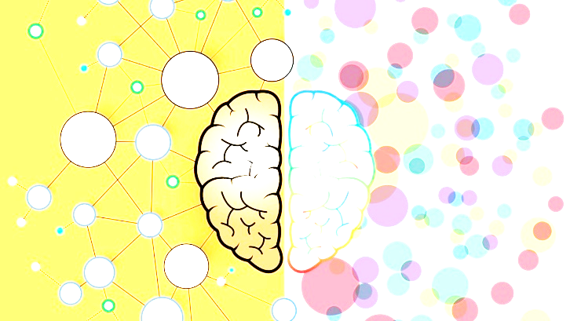
Beyond the Diagnosis: Getting to Know the ADHD Brain

Presented by: Katelyn Mabry- Author of the children’s book, “Hi, It’s Me! I have ADHD,” Speaker, Educator, Reading Specialist, ADHD Advocate
“The best choice I ever made was to build a relationship with my child’s ADHD!” ~Anonomous

What is Executive Function and how does it relate to ADHD?
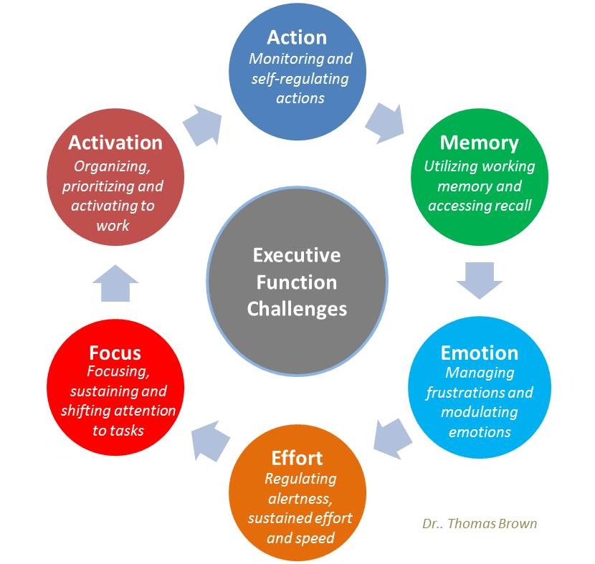
These are the areas that we see the most struggle, because often there is a difference of up to 3 years in the development of these skills when looking at the ADHD brain.

EVERY child is different…take a minute to look at these different areas and circle the ones that speak the loudest into your child’s challenges…

Note the tools and strategies you have already tried using in the areas of struggle and star those that you need help knowing where to start…

Here are some key pieces to put into place…

- Develop organizational strategies/tools with your child:
(Working memory, activation, effort, and focus)

- Help them create a place for everything

- Develop a Schedule with the child
  - Color coding/Label things
  - Checklists (written or visual pics)
- Have your child repeat what the expectation is…
The homework struggle is real…
A-ddress the struggle and put a name to it
B-reak down task into manageable parts
C-over what is not being worked on

- Develop an active lifestyle for the active brain:

- Schedule exercise breaks into your daily routine

- Be mindful of their exercise needs…consider time of day, type of exercise and change it up to keep child’s interest.

- “There are calming exercises that slow the system and can have tremendous benefit,” said Nancy Konigsberg, MA, an occupational therapist specializing in pediatrics in N.J. “For example, there are yoga programs designed to help calm children with ADHD and allow them to focus better.”

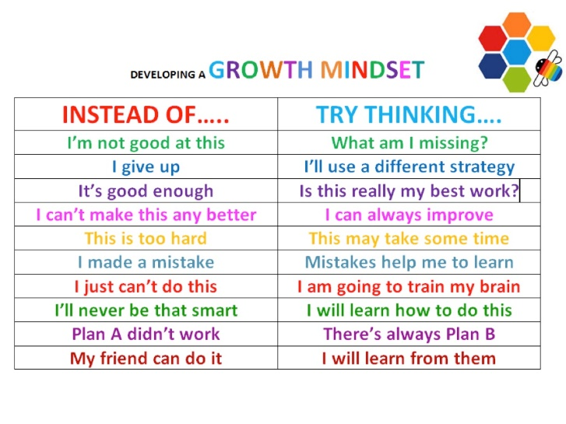
- Develop coping methods with each child:
4 B’s:
- Be aware of needs (i.e. fidget, sensory input)
- Breaks from Busyness
- Breaths to calm body and mind
- Blanket mind with positive thoughts
  - Continually working on developing a positive mindset is key
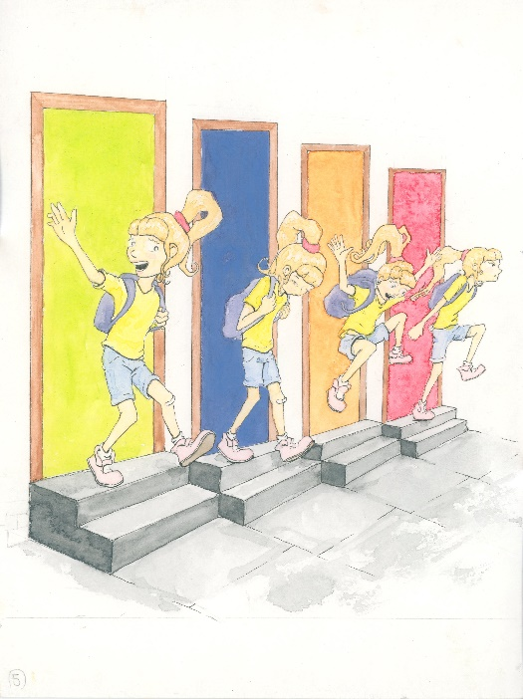
- Emotional Regulation-
- We have the same emotions, but just feel with more INTENSITY…
(https://chadd.org/adhd-weekly/rejection-can-more-painful-with-adhd/)
What can we do?
Give the emotion a name
Identify the trigger
Voice the feeling and practice the pause
Educate your mind on turning to gratitude

- Friendships/Relationships-
- Sometimes it feels like other kids don’t understand…
(https://www.additudemag.com/help-your-child-make-friends/)
- Find ways to help facilitate friendships.
  - Plan play dates, meet kids at a park, etc.
- Get your child involved in team sports or group activities.
- Practice ways to appropriately interact with and talk to peers.

Here is a guide to help with the process of studying at any grade level…
- Always plan a study schedule so they know what to expect
- Determine best time of day to study
- Have breaks implemented early and often
- Develop ways to include your child’s strengths and interests

- Incorporate fun and a reward system for working so hard
- Study with them at different angles until they understand concepts

- An acronym can be used to help remember the tough stuff

- Give tips on how to find answers in a storybook/textbook
- Illustrate the use of color coding to recall different concepts
- Form a fun practice test after studying
- Take time to praise the study efforts of your child!
“ADHD is not a disability, it’s a different ability!”

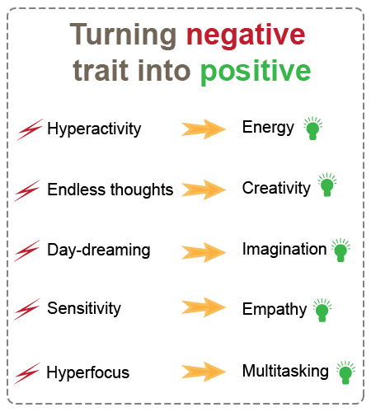

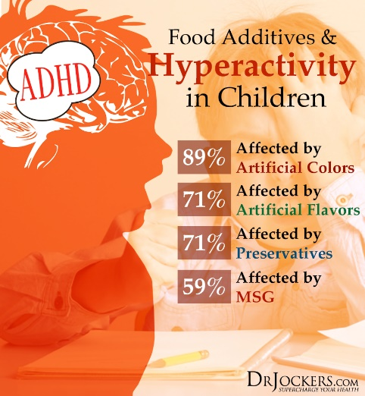

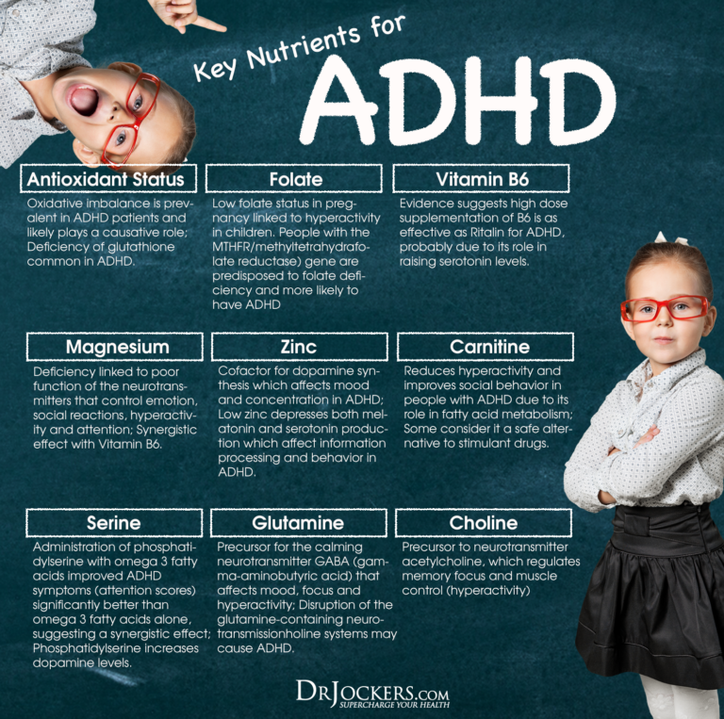
www.drjockers.com/adhd

