Transforming Behavior
by Exploring the Mind of a Child With ADHD

Presented by Katelyn Mabry~ Author of the children’s book, “Hi, It’s Me! I have ADHD,” Early Childhood Educator, and Reading Specialist
“A child is like a butterfly in the wind.
Some can fly higher than others, but each one flies the best it can.
Why compare one against the other?
Each one is different. Each one is special. Each one is beautiful!” ~Anonomous

Fact #1: 5-11% of children ages 4-17 are diagnosed with ADHD
- 13.2% of boys are more likely then 5.6% of girls to be diagnosed
- Often girls go undiagnosed until adulthood due to symptoms being misunderstood

Fact #2: ADHD demonstrates itself on a spectrum of mild to severe and can present either impulse control and hyperactivity, attention struggles, or a combination of both. It is a developmental delay/difference in how our brains are wired…

Fact #3: The ADHD brain functions differently and “Executive Function” is highly affected.
- Children on average are 3-5 yrs. behind in different areas of executive function. ~Thomas E. Brown, Ph.D.
- “The way I describe it is like having a Ferrari for a brain, but with bicycle breaks!” ~Dr. Hollowell

Fact #4: Children with ADHD struggle with Emotional Dysregulation and maintaining relationships due to misinterpreted or negative interactions with others.

Fact #5: ADHD does not equal bad parenting or teaching…children with ADHD are on average highly intelligent, but
simply struggle with demonstrating “negative behaviors” due to the way their brain works…How can we help?!

“The best thing I ever did was welcome ADHD into our relationship as a friend!”
*Get to know it *Learn the struggles *Identify the strengths *Love it

Find the student’s “Hyperfocus” and channel it!
- Interest inventories/interview
- When a child is visibly struggling with a concept, incorporate interest to teach the skill at hand.
- Help student identify their “hyperfocus” so they can learn to utilize this super power when possible!
What are Executive Functions? The Processes of the brain, including higher-level thinking and behavior, that are affected by ADHD. Children who struggle generally need training in how to plan, predict and self-monitor.
Children with ADHD have delays in one or more of these areas and the struggle may look something like this…
Attention Control:
Difficulty differentiating what to pay attention to and what to ignore
How can we help:
- Acknowledge the struggle and love them through it.
- Give grace in the moment and the gift of reminders and tools for success.
    - Build curiosity
    - Ask questions
    - Identify learning styles and adjust activities accordingly
    - Create emotional attachments

Cognitive Inhibition: Struggles to tune out stimuli that is irrelevant
to the task at hand.

- Struggles with mood regulation
- (i.e. experience sudden high anxiety with high levels of stimuli)
- Perseverative negative thoughts
- (i.e. “What is wrong with me?! Why can’t I do this?! I hate myself,” etc.)
- Struggles with completing schoolwork at home
- Struggles with completing in-class work independently due to the inability to tune out stimuli. We can help by…
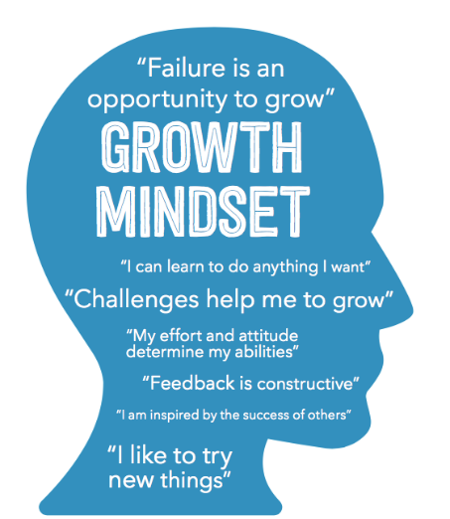
developing coping methods with each child:
Be aware of needs
      - Fidgets, weighted vest, chew necklace, doodles to focus, kinesthetic learning, etc.
Breaks from Busyness
Breaths to calm body and mind
Blanket mind with positive thoughts

Inhibitory Control:
Inability to control or stop an impulsive reaction to an activity or responding to others.
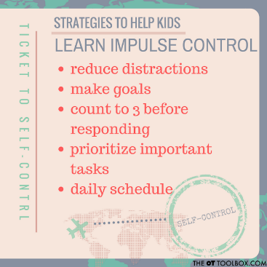
When a child with ADHD displays an impulsive behavior, how do you respond?
Some food for thought…
Direction vs. Discipline- Although discipline is necessary at times; be mindful of responding vs. reacting to behaviors.
Verbalize…” I see in you” statements that speak to the child and not the behavior…
Remember…They beat themselves up internally more then you know!
Verbalize…” How can I help” so that they feel you are on the same team of toward growth.
Remember…They often feel as though something is “wrong with them” and that they don’t know how to ask for help.

Develop an active classroom for the active brain:
Schedule exercise breaks into your daily routine...
- Begin the day with stretching/movement, mid-day dance party, and end the day with a yoga session!

Be mindful of student’s exercise needs…
- Consider time of day, type of exercise and change it up to keep child’s interest
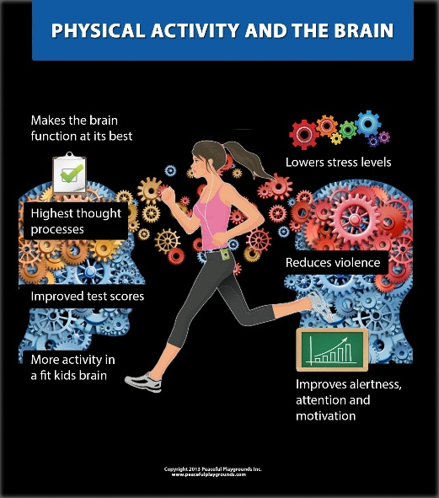

Working Memory:
Children with ADHD are…
- 4x more likely to struggle with working memory then a typical child.

- Given information that gets disorganized or lost in the process.

- Losing information before being able to use it.

Struggles to retain information given and therefore appear forgetful
      - Help them create a place for everything.

      - Create an individual checklist for the student to use during the scheduled day. Use images and/or words.

      - Have the student repeat what the expectation is…

Cognitive Flexibility:
The brain struggles to transition from thinking about one concept to another.

- Task Switching: Unconsciously switching from one task to another…
    - Often, when children with ADHD are asked to think about more than one concept, they tend to shut down.
- Cognitive Shifting: Consciously shifting from one task to another.
    - Many children with ADHD are unable to shift gears to complete a cognitive task presented in different ways.

Emotional Dysregulation-
Struggles to regulate emotions at an age appropriate level
- Children with ADHD are often hyper-emotional and struggle with the act of controlling how they feel.

    - They don’t feel different emotions then peers, only more heightened emotions, with more intensity.

- Mood swings often take on another diagnosis but are simply a symptom of ADHD.

The Relationship Struggle: Building Lasting Friendships
We need to…
- Educate students on mental and emotional differences…
- Empower students to unconditionally value friendships…
- Encourage students to connect to the similarities they see in peers and give grace to the challenges…

Questions?

Tips while teaching a child with ADHD…
Be flexible with lessons
Encourage curiosity
Advocate for students when they need assignments adjusted
Warm up the student to complex concepts (break into pieces)
Always engage students in taking risks during learning
Remind students that using their imagination will exercise their brain
Educate peers that every child is unique and has different learning needs.

Here is a fun acrostic poem that has homework tips for parents of children who are diagnosed with ADHD…
Always plan a study schedule so they know what to expect
Determine best time of day to study
Have breaks implemented early and often
Develop ways to include your child’s strengths and interests

Incorporate fun and words of affirmation for working so hard
Study with them at using a variety of methods until the concept sticks

An acronym can be used to help remember the tough stuff

Give tips on how to find answers in a storybook/textbook
Illustrate the use of color coding to recall different concepts
Form a fun practice test after studying
Take time to praise the study efforts of your child!

